A Guidebook for Transition to Independence
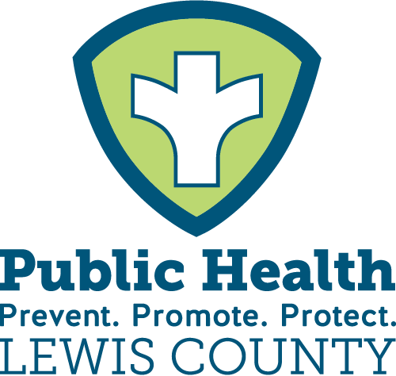

What is next for individuals with disabilities after high school?
Welcome to the Guide to Transition Planning for Life After High School
The purpose of this guide is to assist families in understanding the transition planning process from high school to life after high school. When families are knowledgeable about the transition process and invited to participate in the process, students with disabilities experience improved post-school outcomes in areas of employment, postsecondary education and independent living.
This guide is intended to be utilized with families and school districts as they embark into the transition process. Throughout this guide are a variety of resources and information for families and students. Families and students are encouraged to review the entire guide and reach out to the Office of Special Education: Transition Specialist or the Family and Community Engagement Center for further support or resources in the transition process.

www.boces.com/crpc
www.osepartnership.com

The Transition Taskforce of Lewis Country was made up of the following members:
Karen Boliver - Associate Director at NRCIL
Sara Brooker - Parent
Karlene Cimo - Community Relations Manager at LIFEPlan CCO NY
Mary Compo - CSE Chair at Lowville Academy
David Kudgus - Aging Out/School Transition Coordinator at NYS OPWDD
Lisa Hetzner - Staff and Workforce Development Coordinator/One Stop Manager
At DSS
Rebecca Kelly - Coordinator of Children with Special Needs Program at Public
Health
Brandi McCanney - Director of School to Work at ARC
Nicole Nucci - Developmental Disabilities Regional Office 2- Local School
Transition Coordinator Lead
Allyson Petrus - Public Health Specialist with Lewis County Public Health;
CYSHCN Aide
April Seymour-Ritz - Early Intervention Coordinator
Jerry Switzer - Vice President of Program Services at the ARC
Steve Virkler - Lewis County Office for the Aging/NY Connects
Emily Worden - Resource and Referral Specialists with Family and Community
Engagement Center
Lamanda Jackson- NRCIL Administrative Assistant/ Family Support Team Leader
Stephanie Harris- Disability Resource Coordinator, Jefferson/Lewis Work Place

This team has identified resources that will help individuals become successful while transitioning through and from high school in order to navigate adult services. It is important to learn and understand the larger community that you are entering and engaging in.
Why is this important?
Transition Planning is the ongoing process of preparing students with a disability for the adult life that they choose after high school. A successful plan is a result of a comprehensive team planning that is driven by the dreams, desires and abilities of students. A transition plan provides a basic structure for preparing an individual to live, work and play in the community, as fully and independently as possible.
When students exit the school system, they will no longer receive the same supports and services. Some questions to consider when thinking about life after high school include: What will happen in their life beyond the school schedule? What will their weekly schedule look like? What kind of activities will be on their calendar? Where will they work or live?
The transition process is a “big picture” concept but yet it must unfold on a daily schedule. Keeping the big picture in mind will help guide the everyday activities that will facilitate the achievement of the student’s transition goals. Included in the big picture are three questions that should be discussed with the student in the transition planning process:
Where are you now?
Where do you want to go?
How do you get there?
These questions and more are discussed with the team known as the Committee on Special Education (CSE) that is made up of the student, their family, school staff and community organizations (when appropriate).
Transition planning is an ongoing process that is student-centered, collaborative effort and across multiple school years.
Students and families can often find transition planning to be an overwhelming process and may be unsure where and how to begin. The Transition Taskforce has put together this handbook and a guide to help families navigate transition from high school to adult life. Students and families are encouraged to connect with their school counselors, CSE team, Family and Community Engagement Center for more ideas, resources and support.
Below is a comprehensive checklist from an early age to school exit that families can use as a general guide.
Disclaimer: This document was funded by the New York State Department of Health using federal Health Resources and Services Administration Title V funding. The opinions, results, findings and/or interpretations of content contained therein are the responsibility of the Contractor and do not necessarily represent the opinions, interpretations, or policy of the State or Federal funding agency.

Embedding Activities for Transition Skills
in Standards–Based Instruction
Post-school outcomes are the most important aspect of successfully transitioning from high school to college and career fields. There is a necessary requirement to engage students in activities that will expose them to college and career activities, (i.e. Career Explorations, Job Shadowing, Work Sampling, Services)
Learning, Internships, Paid Employment, Apprenticeship, and/or Mentoring) and to provide opportunities for lessons in IEP participation and career research. Experiences should be selected that will support a student’s postsecondary goals regarding college and careers. For some students, they will participate in experiences that are more focused on employment, while others will participate in experiences directly related to college preparation. Participation in the activities should inform the transition assessment process and increase students’ skills, in preparation for their postsecondary goals.
For students who have a postsecondary goal of attending a two- or four-year college, identifying time in the school day to complete a transition-related curriculum and/or work-based learning experiences in high school (e.g. developing career awareness skills, participating in work experiences) and possibly completing a transition curriculum, such as “Self-Directed IEP,” may lead to greater success in postsecondary education (Test, Mazzotti, et al., 2009). IEP teams composed of family members, school counselors, career technical educators, and, of course, the student may need to be creative in identifying ways to develop these important skills.
Participating in after-school clubs, establishing relationships with community mentors in the school, helping families complete certain activities with their child outside of school hours (possibly through the support of other families, agencies, or the school counselor) are other methods to gain additional knowledge about a variety of careers.

1 - Guardianship and Alternatives
Guardianship
- Legal arrangement where a court gives a person the legal right to make decisions for another person who is unable to make or communicate safe decisions for themselves.
- This should only be considered after alternatives to guardianship (below) have been ineffective. Guardianship may remove many rights from a person.
  - General Guardianship – The guardian has broad control over decision-making authority for the individual with a disability. This may be appropriate if the person has a significant intellectual disability or mental illness.
  - Limited Guardianship – The appointed guardian can make decisions in only some specific areas.
    - Guardianship of the Property or Conservatorship– Responsible for the management of any or all financial resource for the person with a disability. The only exception is representative payee funds, such as Social Security, which may be managed by service providers.
    - Guardianship of the Person – Appointed by the court to manage the personal affairs, such as medical treatment or residential placement of an individual with a disability.
    - Guardian ad litem – Assigned by a judge to act for a person during a court case when they cannot defend their rights or protect their own interests.
Alternatives to Guardianship
Power of Attorney (POA)
- The individual with a developmental disability will appoint a single person as the authority to make decisions on his or her behalf, under agreed upon terms in a legal document. These decisions are in regard to all matters financial, legal, business, or otherwise.
- The individual maintains more control over decisions than with a guardianship arrangement.
- Courts are not involved in POA.
Health Care Proxy
- The individual with a developmental disability will appoint a single person as the authority to make decisions on his or her behalf under agreed upon terms in a legal document. These decisions are regarding medical decisions.
Supported Decision-Making (SDM)
- With SDM, the individual keeps the right to make their own decisions but uses support to do so. The individual chooses trusted advisors, such as friends, family or professionals, to serve as supporters. The supporters agree to help the person understand, consider, and communicate decisions, giving the person the tools to make their own informed decisions.
- There is often a written agreement so that all parties know and understand their rights and responsibilities. Agreements are not legally binding in New York. Oftentimes, however, healthcare providers, landlords, etc. comply with the agreement.

Note Catcher
____________________________________________________________________________________________________________________________________________________________________________________________________________________________________________________________________________________________________________________________________________________________________________________________________________________________________________________________________________________________________________________________________________________________________________________________________________
2 - Financial Supports
Social Security Administration (SSA)
- To qualify for these benefits, the individual must meet SSA’s definition of disabled.
- The individual’s disability must be on a list of conditions that are considered severe and if the disability would prevent him or her from working for one year or more.
Social Security Income (SSI)
- Available to people whose disabilities prevent them from gainful employment.
- In order to be eligible, the person must not have greater than $2,000 in countable resources and must have a limited monthly income. At age 18, the family’s income and resources are not counted, even if the child consigns to live with their parents.
- SSI provides monthly income for food and shelter.
Social Security Disability Insurance (SSDI)
- Income supplements to people who are restricted in their ability to be employed because of a disability.
- This is available regardless of the individual’s income and resources. However, the person must have worked in the past and paid into the SSDI fund.
- Anyone whose disability developed prior to age 22, and whose parent or guardian is either deceased or getting Social Security retirement or disability benefits, may qualify for a form of insurance called Disabled Adult child Benefits.
Representative Payee
- An administrator for all beneficiaries who are incapable of managing their own SSI or SSDI benefits, appointed by the SSA.
- If the individual with a disability does not have income or resources aside from the Social Security benefits, this could be used instead of guardianship of property or conservatorship.

Savings Accounts and Trusts
Achieving a Better Life Experience (ABLE) accounts
- Savings account for disability-related expenses.
- These accounts are not taxed.
- These accounts can be used for an individual receiving public benefits, such as SSI or Medicaid, in order to supplement his or her income without impacting eligibility to receive benefits.
- ABLE accounts are used to pay for qualified disability expenses, which includes anything that helps a person with a disability improve their health or quality of life. This could include costs for education, food, employment, technology, support services and more.
- After the individual with a disability passes away, the money is used for reimbursing the state Medicaid agency for services Medicaid paid for after the ABLE account was created.
Special Needs Trusts
- This can ensure that money will be available for the individual throughout his or her lifetime, and that such money will not impact his or her access to means-tested benefits.
- These trusts can be used for an individual receiving public benefits, such as SSI or Medicaid, in order to supplement his or her income without impacting eligibility to receive benefits.
- Money earned on a trust is taxed each year.
- SNT are supposed to pay for “extra” things that make life more comfortable like vacations, pets, entertainment, home furnishings, assistive technology and therapists not covered by Medicaid, and more.
- After the individual with a disability passes away, the money can be left to a designated person.
Medicaid
- Individuals who qualify for SSI are eligible to receive Medicaid, which pays for many services and provides government-funded health insurance.
- Medicaid also provides government funding for long-term services and supports.

Section 8 Vouchers
- The subsidies provide the means for low-income families, the elderly, and the disabled to obtain decent, safe, affordable housing.
- Eligibility to participate is based on family size, income, and other guidelines. Units must also pass a Housing Quality Standard Inspection and both parties (landlord and tenant) must be in agreement to participate by their willingness to sign into a contract and lease. A voucher can be used to rent an apartment, single home, mobile home, or a mobile home lot.

Note Catcher
____________________________________________________________________________________________________________________________________________________________________________________________________________________________________________________________________________________________________________________________________________________________________________________________________________________________________________________________________________________________________________________________________________________________________________________________________________

3 - Postsecondary Education Options
Students with a disability who are interested in postsecondary education may pursue a college or university, a college experience program, vocational or trade school. Early in the transition process, a student is encouraged to:
Vocational/Technical/Trade Schools
- Schools that can provide the individual with the opportunity to experience hands-on learning. The programs provide training along with academic skills such as reading, writing and math. The programs can also provide experiences such as internships and mentorships.
Community College
- A college offering courses to local residents. Many community colleges offer programs that meet the needs of young adults with developmental disabilities. They put more of an emphasis on the needs and goals of each student.
Four-Year College
- More and more four-year colleges are providing support for students with disabilities. Each school in consideration should be thoroughly researched. A good place to start is the school’s office of disability services.
Differences to Note Between High School and College Special Education
(It will be important for students and families to understand the legal and programmatic differences between high school and college)
- The student is responsible for providing documentation that establishes verification of their disability.
- The Individuals with Disabilities Education Act (IDEA) no longer applies in college. This means, college students do not hold an IEP. They can, however, hold a 504 plan.
- Fundamental alterations of programs are not allowed. There may be classroom accommodations as long as they do not alter the fundamental nature of a course or impose undue burden on instruction.
- Personal services are the student’s responsibility.
- Transportation to and from school is not provided.
- Students are expected to be their own advocates, to the best of their ability.
Local Postsecondary Education Programs
ARC College Works
- A two-year, non-degree certificate program offered on the Mohawk Community College campus to help students receive a college experience while also gaining the skills and knowledge needed to transition them into independent roles. This will include course in subjects pertaining to employment, life skills courses, volunteering, and internships.
Jefferson-Lewis-Hamilton-Herkimer-Oneida BOCES Adult Education
- Offers a variety of services for adults including but not limited to: Center for Business and Industry, HSE Exam/Preparation, Literacy Education, Licensing, Online Courses, & Testing Centers.
Jefferson Community College Lewis County Education Center
- Extension site for Jefferson Community College. Offers a variety of programs.

Note Catcher
______________________________________________________________________________________________________________________________________________________________________________________________________________________________________________________________________________________________________
____________________________________________________________________________________________________________________________________________________________________________________________________
4- Employment Options
The transition from school to work requires a variety of support and collaboration efforts among education and workforce programs. No one institution and collaborative efforts among education and workforce programs. No one institution or organization can provide a full range of services that may be required to serve youth with disabilities. Collaborative and coordinated efforts among education and workforce programs, including vocational rehabilitation, are essential in assisting students with disabilities to make the transition from school to work. Working closely with school districts, Office of Special Education and community providers, ACCES-VR helps to ensure that all youth with disabilities are prepared for employment, postsecondary education and community living when they leave school. ACCES-VR services empower individuals with a disability to make informed choices about their careers by providing a continuum of services to achieve employment outcomes in competitive integrated employment or supported employment. Students and families who are working to find valuable information about job accommodations related to specific disabilities as well as other valuable resources related to work and disability issues can visit THE JOB ACCOMMODATION NETWORK (JAN) website.
Competitive Employment
- A full-time or part-time job with market wages. There are generally no long-term support.
Supported Employment
- A competitive job where the individual receives ongoing supports while working. This will need to be funded through a developmental disability agency.
Customized Employment
- An individual’s strengths and abilities are used to develop a specific role which is created for the individual.
Self-Employment
- The individual’s interests and strengths are matched to a product or resource that can allow them to make money. An example would be baking goods to sell.

Local Employment Programs
Pre-Employment Transition Services
- Job Exploration Counseling – Assists students to explore career options and identify career pathways of interest.
- Work-Based Learning Experiences – Assist students to develop work skills through participation in paid and unpaid experiences in integrated community workplaces.
ACCES-VR
- A program designed to help people with disabilities meet career goals, from entry-level to professional.
- An individualized employment goal and plan will be created for each member. Examples of the types of services are vocational counseling, assessment for career planning, assessment for assistive technology needs, funding assistance, transportation assistance, job placement, and more.
- ACCES-VR services are voluntary. The individual is not required to have an IEP or 504 plan. It is recommended to start the referral process and planning prior to the individual’s junior year of high school.
School to Work
- For individuals in grades 7-12 whose expected outcome is community-based employment.
- Students will work on life skills, independent living skills, work skills, job retention skills, prosocial behaviors, career exploration, job shadowing, internships, college experiences and preparation for community-based employment.
Ongoing Supported Employment
- Ongoing Supported Employment services assist individuals who have achieved employment to maintain or advance at employment.
Summer Youth Employment Program
- Connects youth between the ages of 14 and 20 with career exploration opportunities and paid work experience each summer.
- Participants have the opportunity to explore their interests and career pathways, develop workplace skills and engage in learning experiences that help in developing their social, civic and leadership skills. By participating in structured project and work-based opportunities, youth are better prepared for careers of the future.
Prevocational Services
- Prevocational services prepare individuals for volunteer or paid work experiences. Individuals work on developing skills such as communication, time-management, managing personal finances, job-specific skills such as computer skills, office equipment experience such as telephones, fax machines, or copy machines. For individuals with substance use disorders, learning to interact without the use of drugs in the workplace would be a skill learned in this setting. This service is usually delivered at a program site but may also be delivered in work locations where individuals may gain work-related experience. This service is delivered one-on-one.
Building Abilities and Skills for Employment (BASE)
- Five services offered including job exploration counseling, work-based learning experiences, counseling on postsecondary options, workplace readiness training and instruction in self-advocacy.
- To be eligible, students must be enrolled in an educational program and be eligible for IEP, 504 or have a documented disability AND not have an open case with ACCESS-VR.

Note Catcher
______________________________________________________________________________________________________________________________________________________________________________________________________________________________________________________________________________________________________

5- Housing/Residential
Transition Planning includes considering where a student will live after high school and whether they need residential support. Independent living skills include money management, preparing meals, washing laundry, medication management, transition and more. It will be important to research and explore services with the New York State Office for People with Developmental Disabilities (OPWDD).
Supported Living
- Individuals with disabilities can live independently in a home or an apartment. Minimal services are based on the individual’s specific needs and are provided by caregivers working under the direction of the individual.
Supervised Living
- Direct and intensive support offered 24 hours a day. The individual may live in a house or apartment alone or with others. Life skills can be taught or supported by staff members.
Group Home Living
- Several people with disabilities live together with onside staff who are present 24 hours a day. Instruction focuses on independent living and community activities. The house is owned and operated by a provider agency who also employs the staff. These homes typically house 8 or fewer people.
Assisted Living Facilities/Intermediate Care Facilities (ICF)
- Staff members aid with personal care and activities of daily living such as bathing, grooming, dressing and more. These facilities do not offer complex medical services but can assist with medication.
Developmental Centers
- Large residential facilities on a campus-like setting where residents have intensive needs.

Section 8 Vouchers
- The subsidies provide the means for low-income families, the elderly, and the disabled to obtain decent, safe, affordable housing.
- Eligibility to participate is based on family size, income, and other guidelines. Units must also pass a Housing Quality Standard Inspection and both parties (landlord and tenant) must be in agreement to participate by their willingness to sign into a contract and lease. A voucher can be used to rent an apartment, single home, mobile home, or a mobile home lot.

Note Catcher
____________________________________________________________________________________________________________________________________________________________________________________________________________________________________________________________________________________________________________________________________________________________________________________________________________________________________________________________________________________________________________________________________________________________________________________________________________

6- Case Management and Supports
Peer Supports
- Provides support with advocacy, skills building, agency referrals, transition assistance and more. The support person will relate to the individual with disabilities because they have or have had a common experience.
Health Home Care Management
- Person-centered program designed to assist eligible individuals with services they need. Each individual will be assigned a care manager, who will meet with the individual on a regular basis. The care manager can assist the individual with establishing health care providers, social services, community programs, coordinating services and more. To be eligible, the individual must have qualifying medical and/or psychiatric conditions.
Home and Community-Based Waiver Services (HCBS)
- Optional services available to provide integrated community-based long term care services and supports to qualified Medicaid recipients. These programs can provide respite services, case management, environmental modifications and more.
Office for People With Developmental Disabilities (OPWDD) Care Management
- Care management services providing assistance to qualifying individuals with multiple services such as employment, community and day habilitation, clinical, residential supports and services, and respite services. The individual must have qualifying developmental diagnosis(es) and receive Medicaid to enroll.

Note Catcher
____________________________________________________________________________________________________________________________________________________________________________________________________
7 - Community Programs
There are many community-based services available that can provide resources for transition aged students and families including:
Independent Living Center (ILCs):
- Provide a variety of services to individuals with disabilities including peer mentoring, skills training, resources, housing, transportation and employment
NYS Career Centers:
- These centers aid individuals seeking employment by providing workshops, local career fairs and career counseling.
Respite
- Programs which provide parents and caregivers with short-term care for the individual with a disability. Respites can be planned or on an emergency basis.
Day Habilitation Programs: Without Walls
- This program has more flexibility for engagement in the community.
- Person-centered programs that provide structured activities and specialized supports that will allow for participation in non-employment related activities in the community. These programs are provided for adults with disabilities who have exited the school system and may not be ready or able to participate in the workforce in an effective way. These programs focus on independent living skills and integration into the community.
Day Habilitation Programs: Site Based
- This program provides more structure.
- These programs provide therapeutic treatment with daily life skills. This program is administered at a program site rather than in the community.
Assisting and Supporting People in Reaching Employment (ASPIRE)
- Individuals learn about different opportunities in the community by experiencing them first by volunteering in the community.

8-State Agencies
Students with a disability are encouraged to apply for adult services as early as 17 or during their junior year of high school. Students and families should have copies of health, education and other records readily available as they will be needed for the application process. Each agency’s website contains specific information about eligibility criteria, programs, and services they offer. It may be helpful to invite the state agency or community partners to the IEP meeting so they can assist in developing future goals
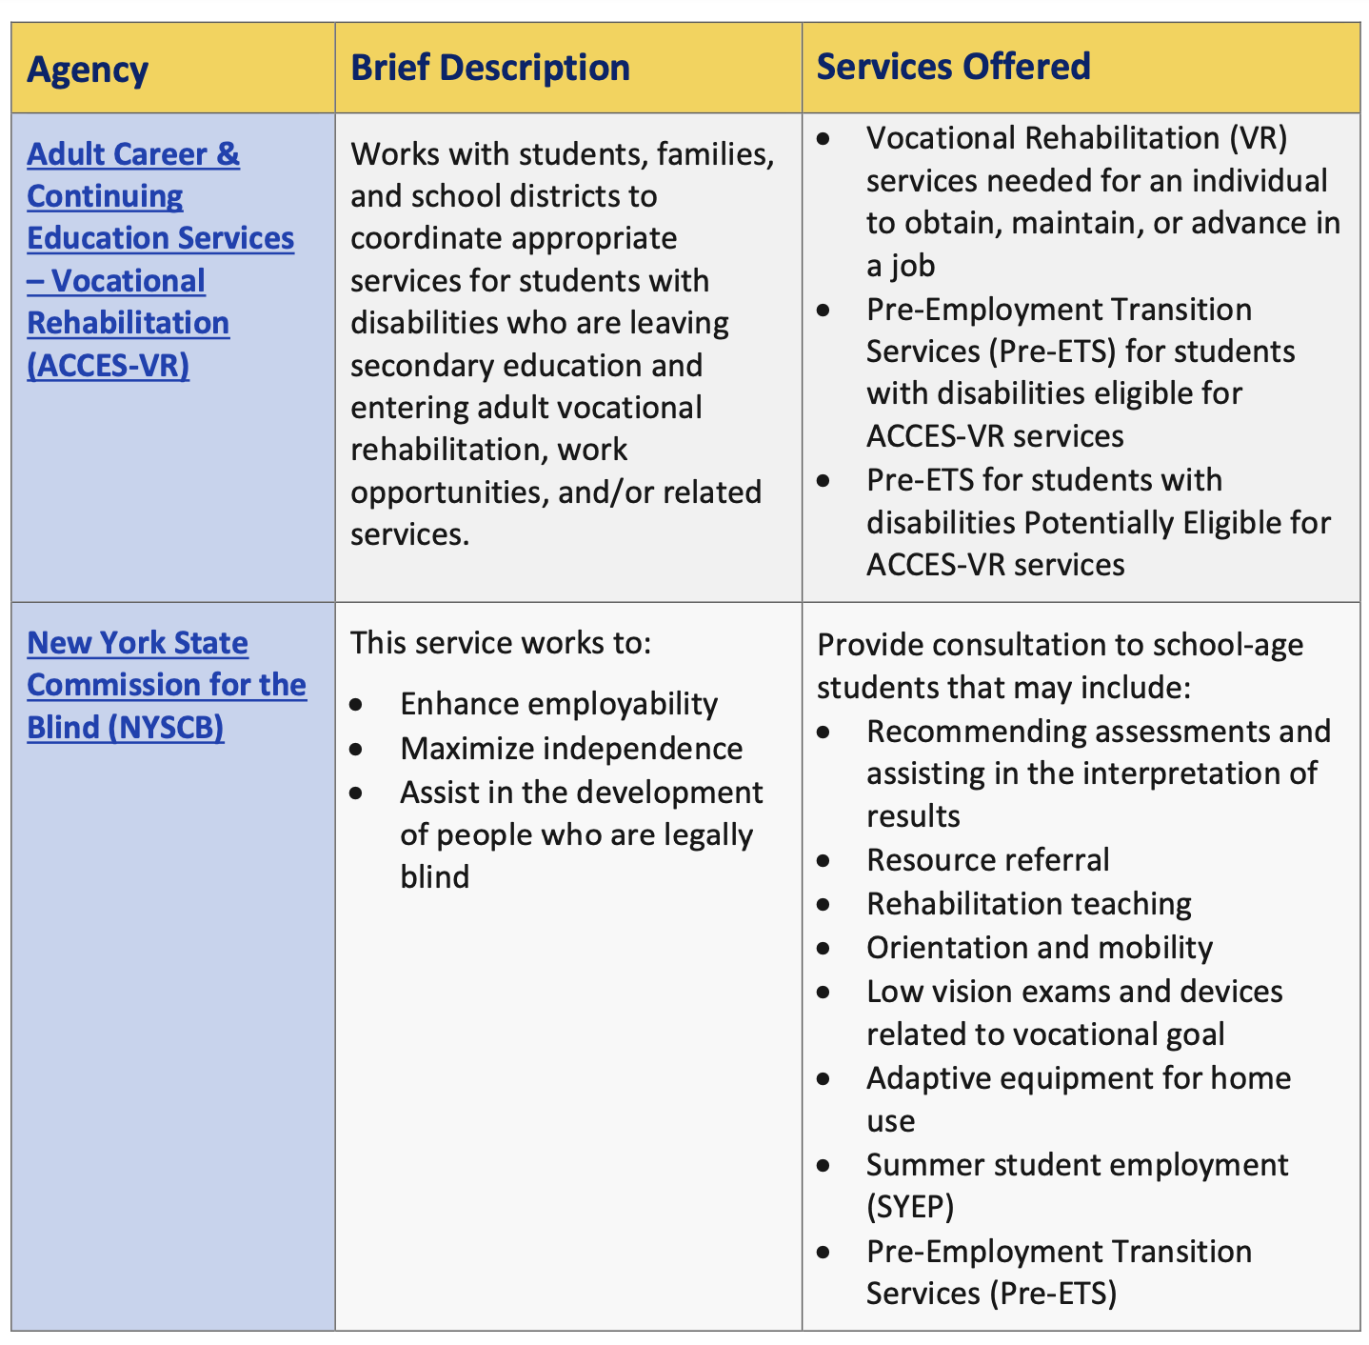

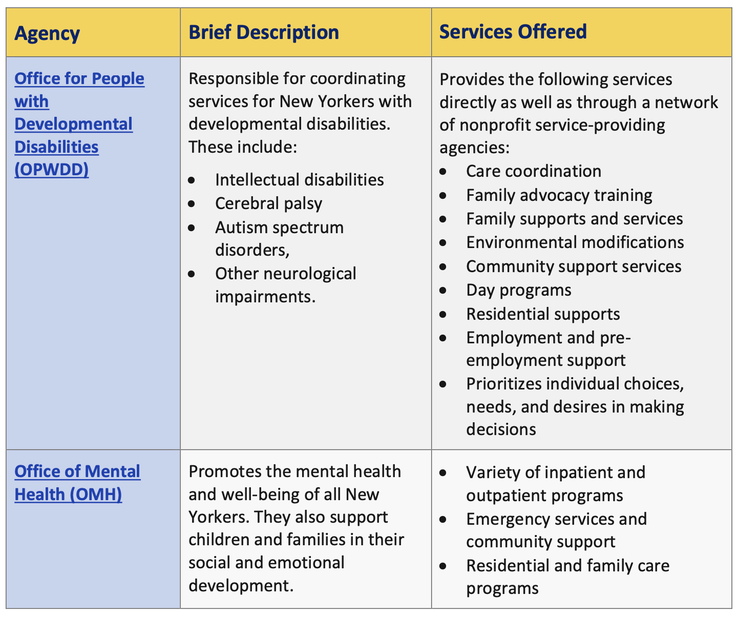
Note Catcher
______________________________________________________________________________________________________________________________________________________________________________________________________________________________________________________________________________________________________
Appendix
Appendix A: Strength-Based Assessments: Parent/Guardian/Caregiver’s Strength- Based Assessment

Parent/Guardian/Caregiver | Today’s Date
Abilities: What are the student’s strengths, talents, abilities, skills, things they like to do? | Favorite Subjects: What are the student’s favorite subjects in school?
Dreams: What are the student’s hopes and dreams for the future? What are your hopes and dreams for the student’s future? | Least Favorite Subjects: What are the student’s least favorite subjects?

Student’s Strength-Based Assessment
Student | Today’s Date
Abilities: What are your strengths, talents, abilities, skills, things you like to do? | Favorite Subjects: What are your favorite subjects in school?
Dreams: What are your hopes and dreams for the future? | Least Favorite Subjects: What are your least favorite subjects?
What helps: What is needed to make your dreams happen? (for example: more information about a course of interest, work experience in my field of interest, extra help with math, etc.). What helps you do a good job and learn best? | Future Learning: What do you want to learn more about?

Appendix B: Planning for the Future with Measurable Postsecondary Goals
Measurable Postsecondary Goals are goals to help with the future planning. These goals describe where a student would like to work, learn and live after high school. They usually focus on the future: educational goals, independent living goals, and so on. Measurable postsecondary goals are an opportunity for teachers and caregivers to support a student with identified steps for achieving the student’s vision for their adult life.
Measurable postsecondary goals are a part of the student’s IEP. These goals may take years to reach and include activities as early as birth all the way through young adulthood.

Training/Education
- What are your favorite subjects in school?
__________________________________________________________________________________________________________________________________________________________________________________________________________________
- What subjects (if any) do you NOT like?
__________________________________________________________________________________________________________________________________________________________________________________________________________________
- What do you want to learn more about? (These do not have to be school subjects; they can be anything you are interested in)
__________________________________________________________________________________________________________________________________________________________________________________________________________________
- Where do you want to continue learning? This could include college, vocational training, driver’s education classes, etc.
__________________________________________________________________________________________________________________________________________________________________________________________________________________

Measurable Postsecondary Training/Education Goal: Using the information above, write a measurable postsecondary goal specific to education/training. For example: I am interested in animal care so I will attend a 2-year college to take courses in animal care.
________________________________________________________________________________________________________________________________________________________________________________________________________________________________________________________________________________________________________________

Employment
The questions below can help you and your students determine a career path, as well as which diploma option may be best for them. For more information specific to New York State (NYS0 diploma options, ask a Transition Specialist or Family and Community Engagement Center Specialist with the Office of Special Education.
- What things do you like to do? List your likes, skills, and talents:
__________________________________________________________________________________________________________________________________________________________________________________________________________________________________________________________________
- What things do you really dislike doing?
__________________________________________________________________________________________________________________________________________________________________________________________________________________________________________________________________
- If you could have any job, what would it be?
__________________________________________________________________________________________________________________________________________________________________________________________________________________________________________________________________
- What do you think you would like most about the job?
__________________________________________________________________________________________________________________________________________________________________________________________________________________________________________________________________
- What other jobs do you think you might like to try?
__________________________________________________________________________________________________________________________________________________________________________________________________________________________________________________________________
Measurable Postsecondary Employment Goal: Using the information above, write a measurable postsecondary goal specific to employment For example: My goal is to work as a dog groomer as I participate in veterinary science courses
_______________________________________________________________________________________________________________________________________________________________________________________________________________________________________________________________________________________

Independent Living
- What do you like to do for fun outside of school or work?
__________________________________________________________________________________________________________________________________________________________________________________________________________________
- Do you plan on moving out of your family’s home at some point in your life?
- Yes (answer questions 3-6)
- No (do not answer questions 3-6)
- When do you plan to move out? ____________________________________________
- Where would you like to live? __________________________________________________________________________________________________________________________________________________________________________________________________________________
- In what type of home do you plan on living after graduation?
__________________________________________________________________________________________________________________________________________________________________________________________________________________
- Who, if anyone, would you like to live with? They can be specific people or general groups such as friends, spouse, etc.
__________________________________________________________________________________________________________________________________________________________________________________________________________________
Measurable Postsecondary Employment Goal: Using the information above, write a measurable postsecondary goal specific to Independent Living. For example: I will share an apartment with a friend. I will ride the public bus by myself and shop in the community.
________________________________________________________________________________________________________________________________________________________________________________________________________________________________________________________________________________________________________________

Appendix C: Transition Service Worksheet
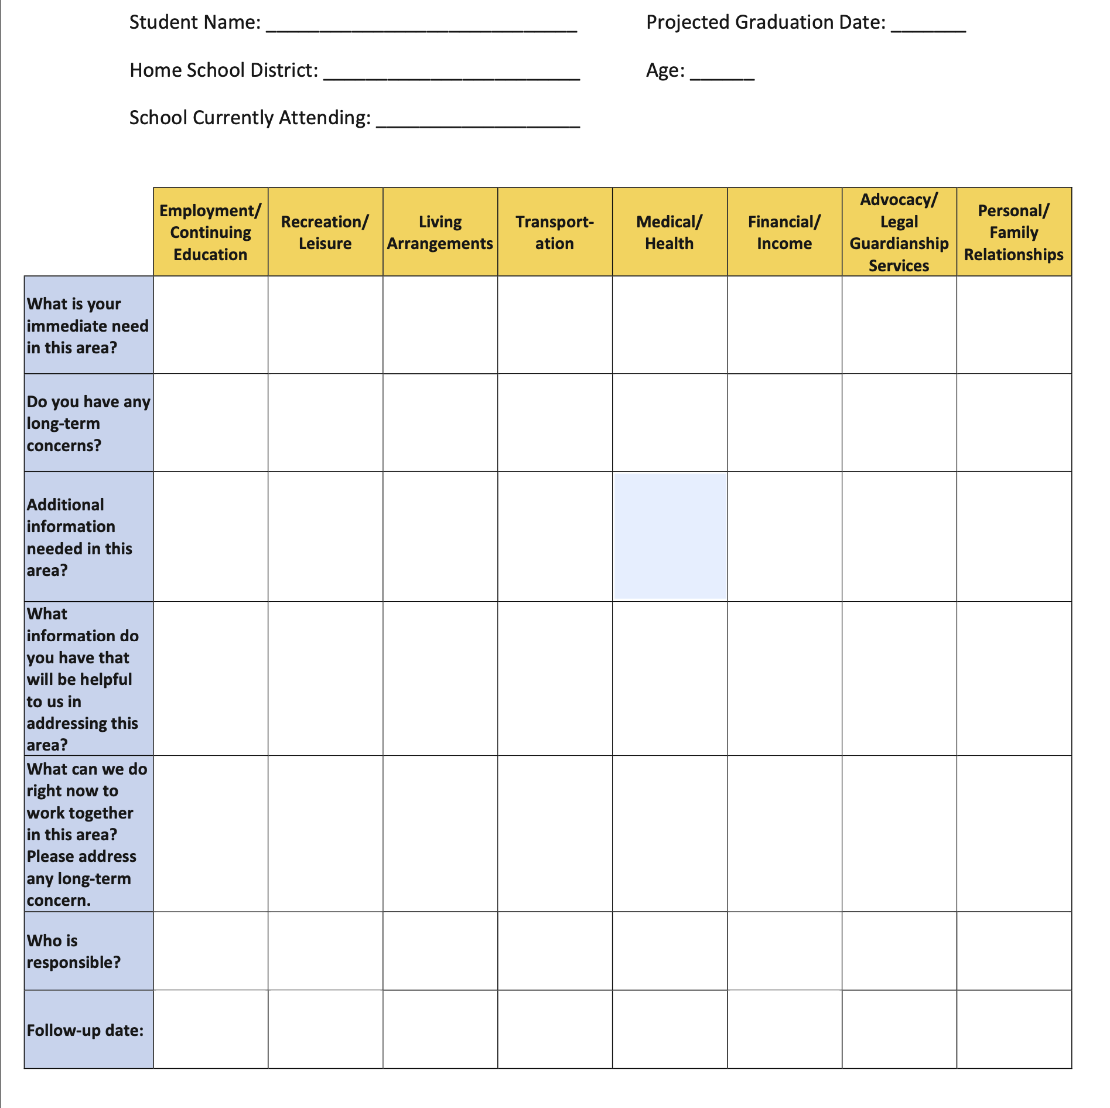

Appendix D: Transition Planning Profile
The Transition Planning Profile is a tool that can be used to think about success in the
workplace. It puts information about strengths, interests, and needs into a simple visual format that can help a student make informed day-to-day decisions about their future based on their desires, strengths, and needs.

For example, a student who is deciding whether to apply for work at a library or at a fast food restaurant can review his profile to see that he prefers working in a quiet atmosphere and at his own pace. This might cause him to lean toward the library. His decision would be to apply to the library because it matches his strengths and preferences.

It is important when using this planning tool to remember that:
• The student’s input is crucial to the success of any planning effort.
• Use language that is easy for the student to understand.
• Feedback from the school and other professionals working with your family can and
should be included in the profile.
• The profile can and should be updated often.
 | Strengths | Hurdles | Accommodations/Skill Development
Self-Determination
Work Tolerance
Interpersonal Skills
Communication Skills
Mobility

Revised October 2024

